# Analysis of Telco Customer Churn data which is focused on retaining the customers

Every month customer of the Telco customers left the service with different reasons such as problem with the phone, multiple lines, internet problem, online backup, tech support issues and streaming TV and movies. The dataset contains totally 7043 entries which gives an opportunity to view the data using different virtualization and to gain more knowledge in it.

In this dataset identifying which on is churn data and which one is not, is an interesting part. However, it is identified that both male and female have created an equal churn data.

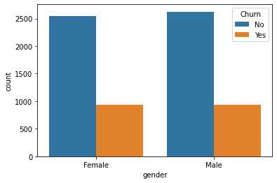

As shown in the below image tenure and gender almost have the same level of infection on the churn data. Few people may like the service but few expects that the service needs to be good and quick process in assisting them. If the organisation delays in providing assistance on the right time then they simply remove the service and move to others.

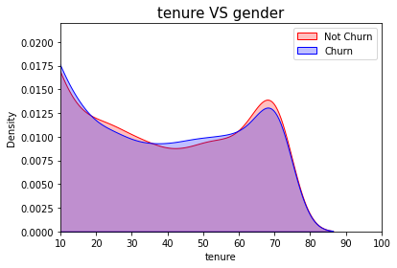

Monthly charges for the services also affect the Telco business because people will compare the charges with other organisation and make decision on continuing or leaving the particular service. Most of the people left the service when they start to think that the organisation is charging more on monthly basis comparing with other organisation still they don’t care about the quality of the service.

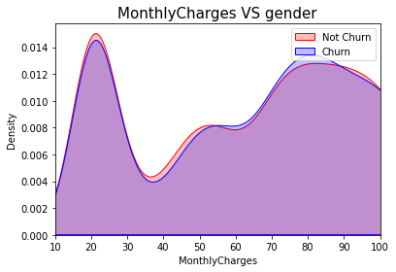

In this case mostly teenagers left the services with different reasons and only 16.21% of senior citizens left the service which means if the organisation focus more on satisfying the senior citizen will helps the organisation to retain 16.21% customers easily.

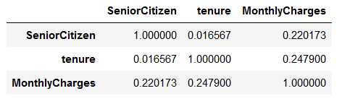

Correlation of the seniorcitizen, tenure, and monthly charges data has been created to understand which affects the organisation services more badly and which thing the organisation have to concentrate more on retaining the customers. The above table shows that the monthly charges is the one of the main negative impact for the organisation. Telco have to focus more on fixing the monthly charges for the services.

By reviewing the monthly charges column it shows that the most of the people left the service due to of it only. When the people use the services for a year or two year contract they won’t left the service quickly. But if the person uses the monthly then it have the highest probability to left the service without any intimation.

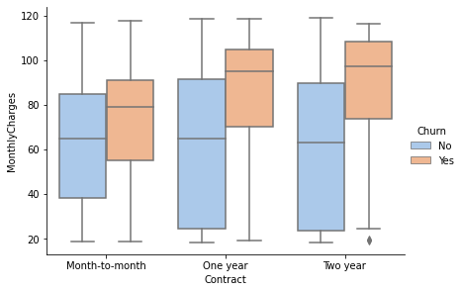

The above image shows the churn data created based on the three category of the payment modes.

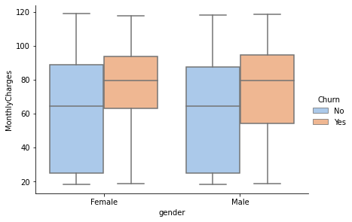

Both male and female have left the services on the monthly charge mode because they may thought that the organisation is charging more to access the particular service.

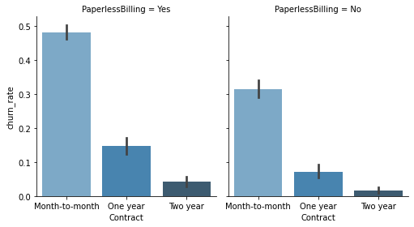

When the organisation allows customers to make the paperless bills then the number of customer stayed with the service is high but when they ask customer to reach a particular place to make the bill and to collect the charge sheet then number of customers from the three different category made some decisions on looking the service provider who allows to make the bill payment without paper bills. Nowadays, people likes to make the payment through online and no one want to make the paper bill payment which is time consuming so telco need to focus more on enabling the paperless bill payments to retain the customers shortly.